


Committee on Committees Minutes

Associated Students
DATE: October 27th, 2025
LOCATION: Pardall Center Minutes/Actions recorded by: Shuyi Sum

CALL TO ORDER: 7:00pm by Lily Strange, Internal Chair

QOTW: Happy midterms season! What is your favorite study spot on or off campus?

A. MEETING BUSINESS

- Roll Call

Name | Note:  absent (excused/not excused)  arrived late (time)  departed early (time)  proxy (full name) | Name | Note:  absent (excused/not excused)  arrived late (time)  departed early (time)  proxy (full name)
Sophia Fei | Present | Yeshua Valdez Rodriguez | Present
Lily Strange | Present | Adam Orenstein | ...
Shuyi Sum | Present | Savanah Aldaba | Present
Oliver Ramirez Carrera | Present
Layla Hakim | Present
Mira Ikladious | Excused

- Acceptance of Excused Absences

MOTION/SECOND: Oliver/ Shuyi
Motion Language: I motion to excuse Mira from today’s meeting on 10/27.
ACTION: Consent

- Acceptance of Proxies

B. PUBLIC FORUM

- EXTERNAL REPORTS

- Advisor’s Report

- Executive Officer’s Report(s)

- Group Project/Member Report(s)
  - Advisor and Senate Liaison Reports

Lily Strange - Internal Chair
    - QOTW: The Geography building, in the first floor lounge or at the Materials Science building 3rd floor
    - OSA: Let’s schedule interviews this week and deliberate next Monday!
    - Hiring for President Pro-Tempore Senior Advisor
      - I just got texted about this today, will follow up for more info, add to the website, let applications come through, then we can interview maybe next week
    - 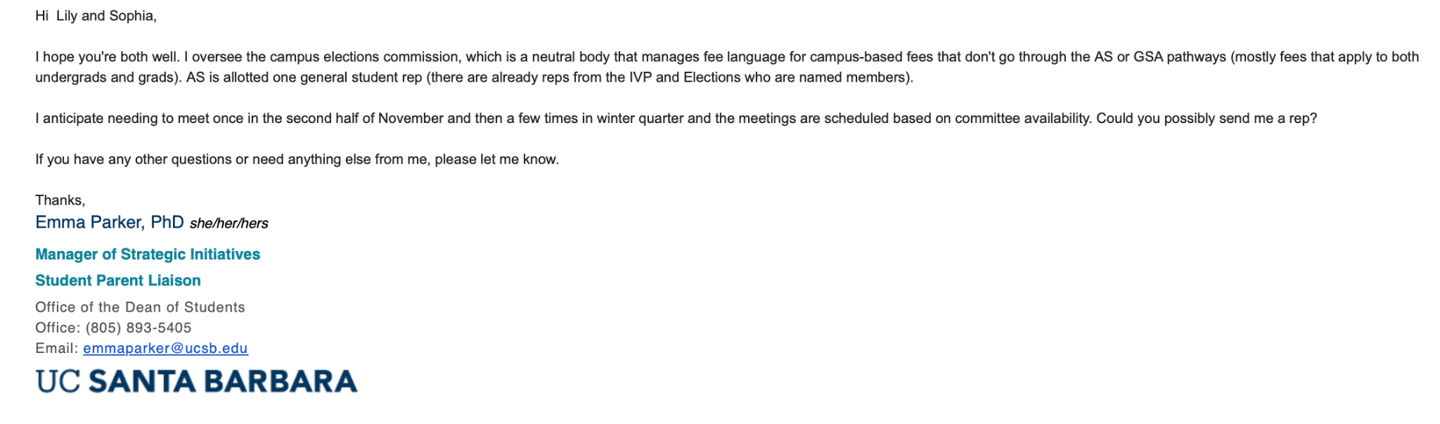
    - Is anyone interested in the above!
      - Oliver
    - Update OSA interview questions → add to the drive
    - Make Gcal for pumpkin patch + Chancellors event
    - Close out positions on the website that have been filled

Sophia Fei - External Chair
    - Sent emails
    - Follow up with ggc

Shuyi Sum - Vice Chair
    - QOTW: DEAN coffee (off-campus) / ILP 4F study lounge (on-campus)
    - Project update:
AS Chairs (for mailing list)
Email Draft
    - Tabling at AS Pumpkin Patch (Thurs 10/30 4-8pm) at Annex
      - 4-6pm: Lily (until 5:45), Layla (likely 4-6), Shuyi
6-8pm: Oliver (6-8), Shuyi (until 7pm) Savanah (6-8)
      - Tabling at Parents’ Weekend (Sat 11/8 10-12pm) Chem lawn
9:30 (setup),10-12pm: Lily, Yeshua, Savanah
    - When2Meet for OSA interviews this week: https://www.when2meet.com/?33219171-k8rNe

Oliver Ramirez Carrera - Internal Liaison
    - Emailed BCUs to check upon their hiring process, if they needed help, if they’re still looking etc…
    - Updated the 25-26 AS positions accordingly
      - Still receiving responses

VACANT - Internal Liaison

Layla Hakim - Outreach and Recruitment Coordinators
    - QOTW: Second floor library red couches, specifically the middle section
    - Collaborated with GGC’s recruitment instagram post as per their request
    - Have been working on open positions fliers (3/3 complete!)
      - Have to remove Zero waste committee and outreach committee, add GGC! - Check the spreadsheet in the morning
      - Displays all 12 of the BCUs with open positions and all of their open positions
        - But should I still display the BCU’s that said their preferred method of advertising as IG or email etc
        - GGC?
      - Where on the drive should I add them, if anywhere?
      - Printing at AS office?
        - And how many should I print? I made them primarily for display but if we think they should be hand-outs as well I can print extra.
    - Planning to table at AS Pumpkin Patch 10/30 4-6pm
    - Maybe tabling sat 11/8 10-12pm (need to see my work schedule first)
    - Get keycard access from AS Main

Mira Ikladious - Outreach and Recruitment Coordinators

Yeshua Valdez Rodriguez - Outreach and Recruitment Coordinators
    - QOTW: During the day, I like to study at El Centro, at night, I like to study at the ILP floor 4, given that I have Key Access
    - Chancellors Fair (Saturday, November 8, between 10:00 AM and 12:00 PM)
      - Provided: A 6' table, 2 chairs, and an umbrella
      - Bring flyers or swag to hand out, host mini-table-top activities, strike up a conversation, and provide a warm welcome to our Gaucho families
      - They are looking for bilingual people to table at this event
    - Did we get our Tabling Supplies?!?
    - I will be gone from Oct 30 to Nov 1. I will be in Philly for the SHPE National Convention
    - LMK if anyone wants volunteering hours, Jimmy from EOP needs help for his Parent and Family Weekend event (Celebración de la Familia) after the Chancellor's fair

Savanah Lizet Aldaba - Outreach and Recruitment Coordinators

Adam Orenstein - Commissioner of Community and Climate

C. Action Items

- ACCEPTANCE of AGENDA/CHANGES to AGENDA

- CONSENT ITEMS

- Approval of our Action Summary/Minutes from:

- ACTION ITEMS

F-1. Old Business:

F-2 New Business:

- DISCUSSION ITEMS

- Discussion Topic

- REMARKS

- ADJOURNMENT

MOTION/SECOND: Oliver/Layla
Motion Language: Motion to adjourn this meeting at 7:27pm on 10/27.
ACTION: CONSENT

